Test: Module 6
Vocabulary



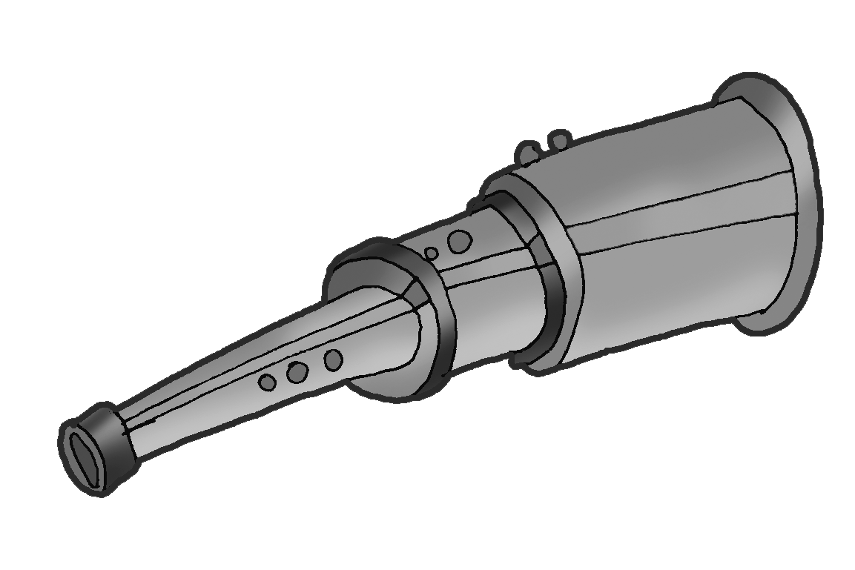
A. Match.
1

2

3


4


5


6


7

7
score

B. Circle the correct words.

1. The surface / temperature outside is 27ºC.
2. He didn’t buy the encyclopedia. He changed / mixed his mind at the last minute.
3. I’m confused / worried. Is this your bag or Jane’s?
4. You can contain / fill this bottle with orange juice and take it with you.
5. What's wrong? You look worried / damaged.
6. I asked her to come with me to the party but she accepted / refused.
6
score

C. Complete the sentences with the words in the box.
after out up forward into of

1. Can you please take care my cat this weekend?
2. Look ! You’re going to crash into that tree.
3. My sister looks me when my parents are away.
4. I look to seeing you again, soon.
5. The scientist pushed a button and the flower turned a tree.
6. A: I don’t understand this word.
6
score
B: Why don’t you look it on the Internet?

Communication

Complete the dialogue with the phrases a-d.
a.Anyway, if you decide to come, call me.c. How could I say no?
b.I had no idea.d. It sounds great but I’m afraid I can’t make it.

Dean Hey Scott, did you know it’s Roland’s birthday today?
Scott (1) .
Dean Well, you didn’t come to school yesterday so he couldn’t tell you. He’s having a
party tonight and everybody’s going. Will you come?
Scott (2) I’ve got a science test tomorrow and I need
to study because I’m really bad at Science.
Dean Poor you! (3) .
Scott OK. I’ll study right after school and try to come later. Hey! What about a present for
Roland? Can you get him something? I won’t have time.
Dean (4) You’re my best friend and I want you to
come to the party. I’ll go to the shopping centre after school. You go home and
study.
Scott Thanks, Dean.
8
score

Grammar

A. Complete the sentences with the correct form of the verb in brackets.

1. If Peter (damage) the car, Dad (not give) it to him
again.
2. When plants (be) dry for a long time, they (die).
3. If she (accept) the invitation, we (go) to the party
together.
4. When you (push) this button, the machine turns off.

7
score

B. Complete the sentences with the correct form of be going to and the verbs in brackets.

1. I (stay) at home and relax. I (not go)
anywhere.
2. A: (Paula / help) us organise the party?
B: Yes, and she (make) the cake, too.
3. A: What (the girls / do) next summer?
B: They (travel) but they (not be) away for more than a month.
7
score

C. Match.

1. Greg had an accident and he’s in hospital.
2. I’ll go to the supermarket. You stay here and relax.
3. I promise I’ll tidy my room tomorrow.
4. Will you help me take out the rubbish?
5. Why are you late again?

a. Thanks.
b. Don’t shout or I won’t tell you.
c. Of course I will. Give me some bags.
d. I’ll go and visit him.
e. If you don’t, you’ll be in trouble.
5
score

Listening

Listen to three short dialogues and answer the questions.

1. What are the students going to do?
a. an experiment b. search the encyclopedia for information
2. What are Nathan and Sally going to do tonight?
a. stay at home b. go to the cinema
3. What does John want to study at University?
a. Maths b. History of Art
6
score

Reading

Read and complete with one or two words.

Gurney Planetarium
How about visiting Gurney Planetarium? If you take a trip with us through the galaxy, you’ll learn all about the planets and the solar system. Why don’t you take a closer look at the stars through our powerful telescope? How long do stars live and what happens when they die? Find the answers to these questions and many more! Visitors can surf the Net here and find information about scientists or watch an amazing 3D film in colour and travel into space. With two tickets you get a space poster from our space shop.

1. If you look through the planetarium’s , you’ll see stars and planets.
2. If you want to learn about , you can surf the Net.
3. If you want to know what space travel is like, watch a .
4. If you buy two tickets, you get a .
8
score

Writing

Write an email to invite your friend to come to your house for the weekend. Mention what you are going to do. Use some or all of the ideas in the box.

read / book listen / music surf / Net eat / pizza
study / science / test watch / DVDs do / experiment
10
score
70
TOTAL score

